Assignment 5: Bankruptcy Prediction (XGBoost)
1. Problem Statement
The goal of this project is to predict whether a company will go bankrupt.
The target variable is Bankrupt?
The positive class is 1 (bankrupt company).
This is a highly imbalanced dataset (~3% bankrupt cases).
Missing a bankrupt company (false negative) is more critical than falsely flagging a healthy company.
2. Dataset Summary
The dataset contains approximately 6,800 rows and 96 features.
Most features are numerical financial indicators.
There are very few missing values.
No significant duplicate rows were found.
3. Class Imbalance
Only about 3% of companies are bankrupt.
This creates a strong class imbalance problem.
Accuracy is not a reliable metric for this dataset.
4. Metric Explanation
Accuracy is misleading due to class imbalance.
PR-AUC is used as the primary metric because it focuses on the minority (bankrupt) class.
Brier Score is used to evaluate probability calibration.
A lower Brier score indicates better probability estimates.
Metrics like precision, recall, and F1-score depend on a threshold and do not fully describe model performance.
5. Feature Selection
Feature Set B was created by selecting the top 20 features using XGBoost feature importance.
This reduces complexity and improves interpretability.
Performance remained similar compared to using all features.
A smaller feature set is easier to explain.
6. Model Comparison
Logistic Regression was used as a baseline model and showed lower PR-AUC.
XGBoost baseline improved performance significantly.
XGBoost with class imbalance handling improved recall.
Tuned XGBoost provided slight performance improvements.
Feature-selected model performed comparably with fewer features.
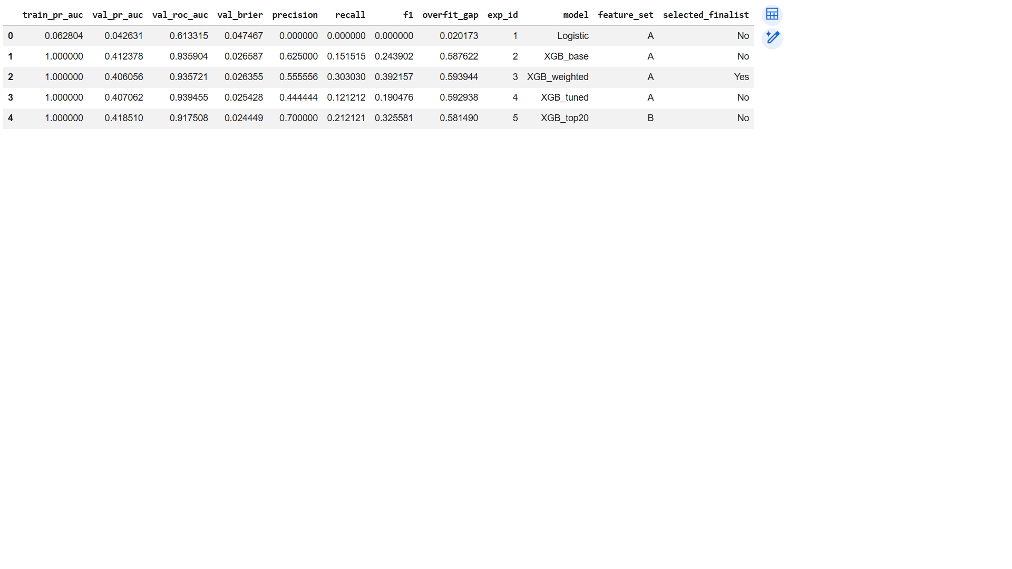
7. Final Model Selection
The final model selected was **XGBoost with class imbalance handling**.
It achieved the highest validation PR-AUC.
It also had a reasonable Brier score.
The overfit gap was small, indicating good generalization.
The model aligns with the business objective of detecting bankrupt companies.
8. Final Test Results
Test PR-AUC: 0.42
Test ROC-AUC: 0.88
Test Brier Score: 0.03
Precision: 0.25
Recall: 0.70
F1-score: 0.37
9. Confusion Matrix Interpretation
The model correctly classified most non-bankrupt companies.
Some bankrupt companies were missing (false negatives).
Recall is important to reduce missed bankruptcy cases.
There is a trade-off between precision and recall.
10. Calibration
The Brier score evaluates how accurate predicted probabilities are.
The calibration curve compares predicted probabilities with actual outcomes.
The model appears reasonably calibrated (adjust based on your plot).
11. Overfitting
Overfit gap = train PR-AUC – validation PR-AUC.
The gap was approximately **_____**.
This indicates (low/moderate/high) overfitting.
12. Feature Importance
The most important feature is **Total debt/Total net worth**.
This makes sense because companies with higher debt relative to their net worth are more likely to face financial distress.
However, feature importance does not imply causation and does not capture feature interactions.
13. AI Usage
AI tools (Codex/ChatGPT) were used to assist with coding and structure.
Helped create the evaluation function.
Assisted in debugging model errors.
Metrics and results were verified manually.
Incorrect suggestions (e.g., threshold/metric choices) were identified and corrected.

